PRIPREMA ZA PROVJERU ZNANJA: UNIT 4 (11.05. pon 11:00-11:45)

- SAT What's the time?
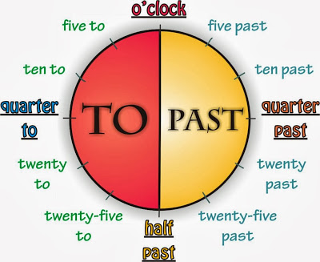
Ta fotografija korisnika Nepoznat autor: licenca CC BY-SA-NC

Kad govorimo koliko je sati minute uvijek dolaze na 1. mjesto:
6:20 – It's twenty past six. 8:35 – It's twenty-five to nine.
10:05 – It's five past ten. 4:50 – It's ten to five.
-----------------------------------------------------------------------------------------------------------------

- ON/AT
ON Monday he gets up AT half past seven. (7:30)

ON-koji DAN? AT-u koliko SATI?
We go to school on Monday. We go to school at quarter to eight. (7:45)
-----------------------------------------------------------------------------------------------------------------

- PRESENT SIMPLE – sadašnje vrijeme, služi za izricanje rutina i navika

I brush my teeth every morning.
My parents go to work at half past 8. (svako jutro)

No, kad je subjekt u rečenici he / she / it glagolu dodajemo nastavak -s

He plays the piano.
The first lesson starts at 8 o'clock.

Na isti način u negativnom obliku pazimo koji je subjekt u rečenici, pa razlikujemo DON'T (svi ostali) ili DOESN'T (he/she/it)

I don't like cheese. She doesn't take the bus to school.
You don't go to school every day. He doesn't speak English.

Isto vrijedi i za upitni oblik:

Do you have a brother? Does she go to church every day?
Do they walk to school? Does he play tennis?

Nakon does ili doesn't glagolu ne dodajemo nastavak -s

--------------------------------------------------------------------------------------------------------

- WH-QUESTIONS
(Why-zašto, When-kada, Where-gdje). Wh + DO/DOES + SUBJECT
Where do you play tennis?
When does Tina get up?
Why does he walk to school?
-----------------------------------------------------------------------------------------------------------------
VAŽNO!
Test će biti otvoren na stranici Socrative
Room: ZELIC5125
Datum i vrijeme: 11.05. ponedjeljak 11:00 – 11:45

